**KRYPTON v1.2 USER MANUAL**

E-PRAYOG, IIT Bombay

(Wadhwani Electronics Lab)

**CONTENTS**

1. **About Krypton**
2. **Installation and getting started**
3. **Pin assignments for on-board peripherals**

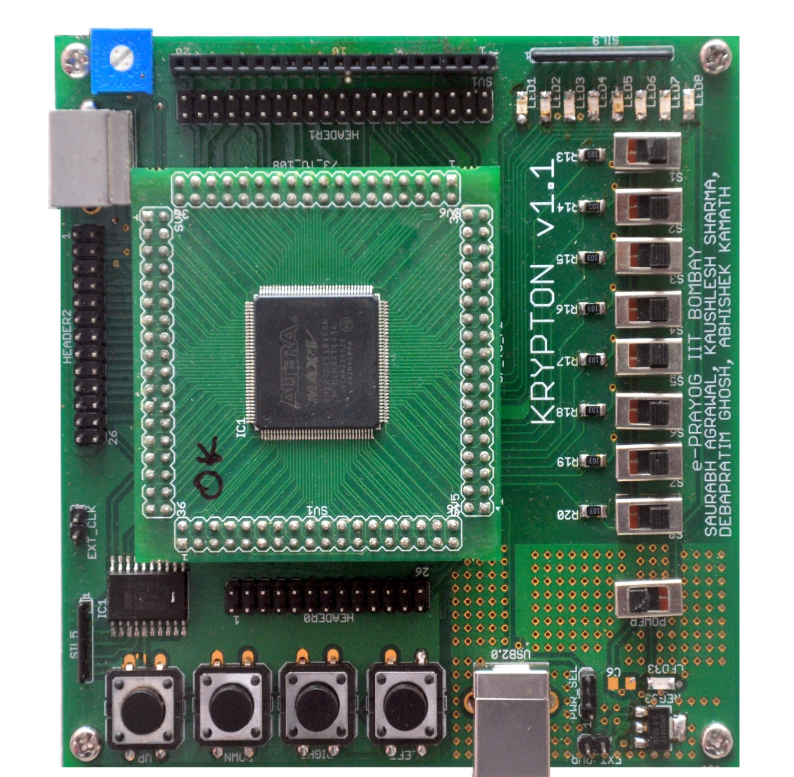

**Chapter 1: About Krypton**

Krypton v1.1 (hereafter referred to as Krypton) is a 5M1270ZT144C5N CPLD-based board developed at e-Prayog, WEL Lab, IIT Bombay under the Virtual Labs Project by the Ministry of Human Resource and Development (MHRD), Government of India. This is a low-cost solution aimed to cater to the needs of undergraduate and graduate electrical/electronics engineering students in a course in digital design and thereafter, design of fairly complex digital systems.

Krypton is currently designed for CPLDs from Altera MAX V and can also support MAX II family devices, Cyclone IV FPGA family devices and also Spartan 6 FPGA family devices. All the above family devices have been tested successfully. This feature of Krypton makes it very useful as the platform can be used as a programmer for many devices and also for development of customized applications where on board peripherals are not used. The modular design of Krypton facilitates the use of CPLD module for much ambitious and complex project development. The Top module which is Hot-Socketed consist of a 144 pin TQFP integrated circuit of which the pins are routed systematically to the edges making it easy to use for other customized application. Second it consists of a 50MHz crystal oscillator soldered on the bottom surface of the PCB which can be easily changes according to developers needs. Third it consists of 2 power indicator LED indicating proper power supply to the device.

Krypton as a whole consists of some very useful peripherals and connectors that can be used for project development by the beginners and intermediate level students and hobbyist. For the development complex projects CPLD hot-socketed module can be used with customized platform. Further a brief introduction of all the peripheral is given which will be discussed in greater detail.

**Board Features and specifications:**

* Device independence: supports Altera MAX V, MAX II, Cyclone IV, and Xilinx Spartan 6 any JTAG compatible device
* Device used in Krypton v1.2: 5M1270ZT144C5N (refer Device Handbook(1) for more details)
* Powered and Programmed through USB with facility to be powered externally
* 8 inputs switches
* 8 outputs LEDs
* 86 programmable GPIOs
* Onboard clock of 1Hz generated using 555 timer as a astable multivibrator
* 50 MHz crystal oscillator
* External clock input
* 4 buffered push buttons with hardware de-bounce
* PS2 connector for Mouse/Keyboard interface
* LCD/GLCD connector

**Important Notes:**

* Do not touch any IC with your hands as they may be damaged due to electrostatic discharge, moisture etc.
* When using an external supply to power the board, use only a single regulated +5V DC supply
* All input voltage levels must be 3.3v
* Use external power supply for application utilizing high power
* When using external power supply change the power select jumper position
* Carefully attach detach Hot-socketed module, GLCD/LCD module
* Interfacing to be done only when power is off
* Improper connections may short power points which will damage the board

**Chapter 2: Installations and getting started**

**Installing the Drivers:**

**For Windows:**

1. Extract the krypton related material to any directory.
2. Plug Krypton to a PC with Windows/Linux via USB and switch on the power, red LED should glow on both Mother and hot-socketed daughter board (a total of 3 LED glows 2 with same brightness and 1 slightly less bright).
3. The **“Found new hardware”**, wizard should open, if new hardware wizard doesn’t pops up the go to devices manager and install the device driver from there.
4. Select **“No, not this time”** and click **next**
5. Select **“Install from a specific location”**, and click **next**.
6. Navigate to the folder containing the CDM20817 drivers in Krypton related material folder extracted in step 1 and click **OK**. Then click **continue anyway.**
7. The drivers will be installed after the same process is repeated 4 times i.e. for Serial Converter A, B, and twice for the two serial ports.
8. Install urJTAG from jtag.exe provided in the krypton related material folder.

It is recommended that you keep a copy of the drivers and materials in your computer. You may need to install the drivers again if a different board is connected. Refer to troubleshooting guide if you find any difficulty installing and/or using urJTAG also refer to our YouTube channel for video tutorials on **Installing the driver and urJTAG(windows)**.

**For Linux:**

1. Untar **libftd2xx1.1.12**
2. In terminal, type **sudo nautilus, i**n nautilus navigate to the folder in which you have extracted **libftd2xx1.1.12 and copy** **ftd2xx.h** and **Wintype.h** in this folder into **/usr/local/include/**
3. Go to **release/build/x86_64 and c**opy **libftd2xx.so.1.**1 and paste in **/usr/local/lib/**
4. In terminal, type the following

* **chmod 0755 /usr/local/lib/libftd2xx.so.1.1.12**
* **ln -sf /usr/local/lib/libftd2xx.so.1.1.12 /usr/local/lib/libftd2xx.so**

1. Untar urjtag-0.10.tar.gz and go to that folder
2. In terminal, type

* **./configure**
* **make**
* **sudo make install**

1. To make sure if the libraries are install properly, after **./configure**, there should be a yes after **libftd2xx** i.e. **Detected libftd2xx : yes**
2. In terminal, type **export LD_LIBRARY_PATH=/usr/local/lib**
3. Remove unwanted modules by typing in terminal

* **lsmod**
* **rmmod ftdi_sio**
* **rmmod usbserial**

1. Install cable drivers by Copying  **“99-libftdi.rules”** to **/etc/udev/rules.d**
2. type **jtag** in terminal

It is recommended that you keep a copy of the drivers and materials in your computer. You may need to install the drivers again if a different board is connected. Refer to troubleshooting guide if you find any difficulty installing and/or using urJTAG also refer to our YouTube channel for video tutorials on **Installing the driver and urJTAG(Linux)**.

**Installing and getting started with Altera Quartus:**

1. Install the latest version of Altera Quartus web edition from Altera’s website. Refer link at (2)
2. Open Quartus, **New project wizard** should open, click **Create a new project.** If new project wizard doesn’t open from **File » New Project Wizard**. Click **next**
3. Create a working directory with short path address for e.g. c:\ MyProject. Next the project name and the top level design entity should have the same name and which is case sensitive. Provide any name with no spaces for e.g. MyDesign
4. An existing VHDL/Verilog file can be added to the project if a design has been already made else it may be left blank if you wish to create new VHDL/Verilog design in the current project directory. Click **next**.
5. Select the programmable device family as MAX V, and 5M1270ZT144C5N from the device list that shows up. Click **next**.
6. In the EDA tools settings page you can select different EDA tools after you have installed an authentic tool version. If you are a beginner you can skip and click **next** else feel free to Google and use the tools in your design.
7. Open a new VHDL/Verilog design file from **File » New** and make the hardware design using the respective HDL.
8. After design is complete compile the design by clicking on **Start Compilation.** Shortcut **ctrl + L**
9. Once the design is compiled, you make the pins assignments as from **Pin Planner** under the Assignments tab in the Menu bar. Shortcut **ctrl + shift + N.** Refer this document for pin configuration and planning.
10. After making the pin assignments compile the design again for the change to take affect.
11. Now generate programming file .svf file. To generate the **.svf** file, select **Tools » Programmer**.
12. Go to File **» Generate JAM, JBC, SVF or ISC file.** Then select **Serial Vector Format (SVF)** in file type and click ‘Generate’. This will create a .svf file in the working directory selected during the creation of new project. Refer to our YouTube channel for video tutorials on **Using Quartus and generating programming files**.

For more information and updates (if any) on using Quartus and new hardware peripherals and driver updates refer to the Virtual Lab website.

**Note:** The complete process from creating the project, defining Top-level entity, selecting the appropriate device, compiling your design, making pin assignments (dedicated to Krypton) and then at least creating the svf file can be automated using TCL scripting. Will be explained in later.

**Programming the MAX V CPLD:**

1. Open the JTAG shell in the UrJTAG folder in windows and type **jtag** in Linux terminal.
2. At the jtag prompt, type **cable ft2232**.
3. You will get a message saying **connected to libd2xx**.
4. Then type **detect,** this will identify the CPLD device and display its signature and device ID etc.
5. In case you have other devices connected to the JTAG chain, you can choose the appropriate device by specifying the corresponding part number. This is optional in this case, as only one device is present in the JTAG chain. Since the CPLD is the only device in the JTAG chain, you can select it by typing the part 0 command.
6. Next type **svf svf_file_location/filename.svf** or **svf svf_file_location/filename.svf progress stop** on the command prompt. The file will now configure the device.

**Chapter 3: Pin Assignments for On-Board Peripherals**

To make the Pin assignments in Quartus go to

Assignments >> Pin Planner or Ctrl + Shift + N

While making the assignments the following information will be required very often.

1. Using the Switches.

|  |  |
| --- | --- |
| **Switch** | **Pin No.** |
| S1 | 48 |
| S2 | 45 |
| S3 | 44 |
| S4 | 43 |
| S5 | 42 |
| S6 | 41 |
| S7 | 40 |
| S8 | 39 |

1. Using the LEDs

|  |  |
| --- | --- |
| **LED** | **Pin No.** |
| LED-1 | 58 |
| LED-2 | 57 |
| LED-3 | 55 |
| LED-4 | 53 |
| LED-5 | 52 |
| LED-6 | 51 |
| LED-7 | 50 |
| LED-8 | 49 |

1. Using the Push Button Switches

|  |  |
| --- | --- |
| **Push Button** | **Pin No.** |
| Up | 141 |
| Down | 142 |
| Right | 143 |
| Left | 144 |

1. On-Board Clock

|  |  |
| --- | --- |
| **Frequency** | **Pin No.** |
| External | 91 |
| 50 MHz | 89 |
| 1 Hz | 18 |

1. PS2 connector of Mouse and keyboard interface

|  |  |
| --- | --- |
| **Pin Name** | **Pin No.** |
| Data | 140 |
| Clock | 139 |

1. GLCD/LCD shared connector

|  |  |  |
| --- | --- | --- |
| **GLCD/LCD Pin No.** | Pin Name | Krypton Pin No. |
| 1 | GND | Ground |
| 2 | VDD | Vcc = +5 V |
| 3 | V0 | GLCD output = -10 V |
| 4 | RS or DS | 70 |
| 5 | R/W | 72 |
| 6 | E | 74 |
| 7 | D0 | 76 |
| 8 | D1 | 80 |
| 9 | D2 | 84 |
| 10 | D3 | 86 |
| 11 | D4 | 88 |
| 12 | D5 | 94 |
| 13 | D6 | 96 |
| 14 | D7 | 98 |
| 15 | CS1 | 102 |
| 16 | CS2 | 104 |
| 17 | RESET | 106 |
| 18 | VOUT | Contrast |
| 19 | LED+ | Vcc = + 5 V |
| 20 | LED- | Ground |

1. GPIO Headers for other peripheral interfacing

|  |  |  |  |  |  |
| --- | --- | --- | --- | --- | --- |
| **Header 0** | | **Header 1** | | **Header 2** | |
| 1 | 2 | 59 | 62 | 109 | 110 |
| 3 | 4 | 63 | 66 | 111 | 112 |
| 5 | 6 | 67 | 68 | 113 | 114 |
| 7 | 12 | 69 | 70 | 117 | 118 |
| 13 | 14 | 71 | 72 | 119 | 120 |
| 15 | 16 | 73 | 74 | 121 | 122 |
| 21 | 22 | 75 | 76 | 123 | 124 |
| 23 | 24 | 77 | 80 | 125 | 130 |
| 27 | 28 | 79 | 84 | 127 | 132 |
| 29 | 30 | 81 | 86 | 129 | 134 |
| 31 | 32 | 85 | 88 | 131 | 138 |
| 37 | 38 | 87 | 94 | 133 | 139 |
| Gnd | Vcc | 89 | 96 | Gnd | Vcc |
|  |  | 93 | 98 |  |  |
|  |  | 95 | 102 |  |  |
|  |  | 97 | 104 |  |  |
|  |  | 101 | 106 |  |  |
|  |  | 103 | 107 |  |  |
|  |  | 105 | 108 |  |  |
|  |  | Gnd | Vcc |  |  |

1. Hot – Scocket on the main board for MAX – V (5M1270ZT144C5N): each side of the TQFP 144 pin package has 36 pins. The table below will help you to make your PCB design to use this hot-socket in your application. The table has 4 main columns each divided in half the top left of each main column is the pin 1 as marked on the MAX-V hot socket. Read the MAX-V data sheet for details information of the device.

|  |  |  |  |  |  |  |  |
| --- | --- | --- | --- | --- | --- | --- | --- |
| **Pin 1 – Pin 36** | | **Pin 37 – Pin 72** | | **Pin 73 – Pin 108** | | **Pin 109 – Pin 144** | |
| I/O 1 | I/O 2 | I/O 37 | I/O 38 | I/O 73 | I/O 74 | I/O 109 | I/O 110 |
| I/O 3 | I/O 4 | I/O 39 | I/O 40 | I/O 75 | I/O 76 | I/O 111 | I/O 112 |
| I/O 5 | I/O 6 | I/O 41 | I/O 42 | I/O 77 | **GND** | I/O 113 | I/O 114 |
| **3.3 V** | I/O 8 | I/O 43 | I/O 44 | I/O 79 | I/O 80 | **GND** | **3.3 V** |
| **GND** | **GND** | I/O 45 | **3.3 V** | I/O 81 | I/O 82 | I/O 117 | I/O 118 |
| I/O 11 | I/O 12 | **GND** | I/O 48 | **GND** | I/O 84 | I/O 119 | I/O 120 |
| I/O 13 | I/O 14 | I/O 49 | I/O 50 | I/O 85 | I/O 86 | I/O 121 | I/O 122 |
| I/O 15 | I/O 16 | I/O 51 | I/O 52 | I/O 87 | I/O 88 | I/O 123 | **GND** |
| **GND** | I/O 18 | I/O 53 | **GND** | CLK50 | **2.5 V** | I/O 125 | **2.5 V** |
| 2.5 V | **GND** | I/O 55 | **2.5 V** | I/O 91 | **GND** | I/O 127 | I/O 128 |
| I/O 21 | I/O 22 | I/O 57 | I/O 58 | I/O 93 | I/O 94 | I/O 129 | I/O 130 |
| I/O 23 | I/O 24 | I/O 59 | I/O 60 | I/O 95 | I/O 96 | I/O 131 | I/O 132 |
| **3.3 V** | **GND** | I/O 61 | I/O 62 | I/O 97 | I/O 98 | I/O 133 | I/O 134 |
| I/O 27 | I/O 28 | I/O 63 | **3.3 V** | **GND** | **3.3 V** | **GND** | **3.3 V** |
| I/O 29 | I/O 30 | **GND** | I/O 66 | I/O 101 | I/O 102 | I/O 137 | I/O 138 |
| I/O 31 | I/O 32 | I/O 67 | I/O 68 | I/O 103 | I/O 104 | I/O 139 | I/O 140 |
| I/O 33 | I/O 34 | I/O 69 | I/O 70 | I/O 105 | I/O 106 | I/O 141 | I/O 142 |
| I/O 35 | I/O 36 | I/O 71 | I/O 72 | I/O 107 | I/O 108 | I/O 143 | I/O 144 |

Links for downloading software:

1. http://www.altera.com/download/software/quartus ii we (Download the Web Edition v10.1 or later. You may be required to register on the website.)

2. http://urjtag.org (It is available free!! No registration required.) Install urJTAG from the above link and then replace the installed folder in program file with the folder provided in the zip file.

For any queries or support contact: [cpld.wel@gmail.com](mailto:cpld.wel@gmail.com)

**FAQ Regarding Krypton (Installation and usage)**

**1. After connecting the Board to my PC running Windows XP, 7, 8 or 8.1, I do not get a “New Hardware Installation Wizard”, what should I do?**

Ans. Don’t worry it’s a very normal thing that can happen with anyone. To install the driver for the hardware connect i.e. Krypton just open device manager and track the changes before and after connecting Krypton via USB cable. Once you know the changes you must see yellow exclamation sign for a few devices. You just need to right click in these devices and click on update driver by giving the path to the CDM driver folder. Follow the step by step process if the above is not clear.

1. After connecting the board to the Windows 7 machine if you are not getting the "New hardware found" Wizard, then you just need to to install the drivers manually for that Right click on "My Computer"

2. Then go to "Properties"

3. Then click on "Device Manager" top left corner.

4. Now when the board is connected and is in power on mode you shall see yellow exclamation sign those are the devices for which drivers need to be installed. So right click on such exclamation sign and click update driver and select the driver location manually.

5. You might need to repeat this for all the drivers that are marked with yellow exclamation in device manager.

6. Once all the drivers are installed (that is no exclamation marks in device manager) then open urJTAG and run the respective commands "cable ft2232 etc...."

**2. “Cable FT2232” command in urJTAG shell cannot detect the connected cable. What shall I do?**

Ans. Well, there might be many reasons to this error.

I. Your drivers might not the installed properly follow the process given in point 1 above.

II. Your USB port might not be working as it should, try changing the USB port.

III. Your USB cable might not be working, try changing that.

IV. Your PC might not be supporting the USB communication due to security issues, try detecting the board in some other PC.

V. Check power indicating LED on board. 3 leds should glow whenever the board in powered on One just near the power switch and 2 LEDs on the top MAX V daughter board. If at all any of the LEDs not glowing power of at once and check for any short circuits on board. Do not use the board in this condition.

**3. I am very new to Reconfigurable Hardware design and configuration, where shall I begin learning?**

Ans. Plenty of good online resource is available to start learning HDL Verilog or VHDL, Of course you need to have a basic knowledge of Digital Logic design. Apart from that to use Krypton you just need to simple things like carefully reading the user manual.

If you follow the instructions, then playing around with the on board peripherals is safe and fun. Randomly plugging wires and power sources into your Krypton, however, may damage it or your PC. Bad things can also happen if you try to connect things to your Krypton that use a lot of power; LEDs are fine, motors are not. Whenever using the GPIO pins please remember the operation voltage of the device which is 3.3 V. Never supply more than 3.3 V as input to krypton, which will surely damage the Board. GPIOs are not pulled up/down, you need to take care of that whenever external peripheral interfacing is required.

**4. What kind of application can I develop using Krypton?**

Ans. A number of applications based on peripheral interfacing have been developed. There is a lot of scope for application development using Krypton. The hot socketed design helps changing this CPLD with a larger and a resourceful CPLD or FPGA. Also will help in custom application development given access to all GPIOs. Refer User manual for the details.